Project Planning Phase

**Project Planning Template (Product Backlog, Sprint Planning, Stories, Story points)**

|  |  |
| --- | --- |
| **Date** | 22 September 2022 |
| **Team ID** | PNT2022TMID53357 |
| **Project Name** | AI-based discourse for Banking Industry |
| Maximum Marks | 8 Marks |

**Product Backlog, Sprint Schedule, and Estimation (4 Marks)**

|  |  |  |  |  |  |  |
| --- | --- | --- | --- | --- | --- | --- |
| **Sprint** | **Functional Requirement (Epic)** | **User Story Number** | **User Story / Task** | **Story Points** | **Priority** | **Team Members** |
| Sprint-1 | Create IBM Service | USN-1 | As a user, I can see a Watson Assistant. | 1 | Medium | Mukesh E |
| Sprint-1 | Chatbot Skills Creation | USN-2 | As a user, I will see the Chatbot having banking- related skills. | 1 | High | Sahari |
| Sprint-2 | Creating Saving Account Action | USN-3 | As a user, I can converse with the chatbotregarding saving account-related queries. | 2 | Medium | Nishant N |
| Sprint-2 | Creating Current Account Action | USN-4 | As a user, I can converse with the chatbot regarding current account-related queries. | 2 | High | Kishore |
| Sprint-3 | Creating Loan Account Action | USN-5 | As a user, I can converse with the chatbotregarding loan account-related queries. | 2 | Medium | Nishant N |

|  |  |  |  |  |  |  |
| --- | --- | --- | --- | --- | --- | --- |
| **Sprint** | **Functional Requirement (Epic)** | **User**  **Story Number** | **User Story / Task** | **Story Points** | **Priority** | **Team Members** |
| Sprint-3 | Creating General Query Action | USN-6 | As a user, I can converse with the chatbotregarding general queries. | 2 | Medium | Mukesh E |
| Sprint-3 | Creating Net Banking Action | USN-7 | As a user, I can converse with the chatbotregarding net banking-related queries. | 2 | High | Sahari |
| Sprint-4 | Creating Assistant & Integrate  With Flask Web Page (Build Python Code) | USN-8 | As a user, I can see a flask web page for bank. | 1 | Medium | Nishant n |
| Sprint-4 | Build HTML Code | USN-9 | As a user, I can web pages integrated with a chatbot. | 1 | Medium | Kishore |
| Sprint-4 | Run The Application | USN-10 | As a user, I can communicate with the chatbot24*7. | 1 | Medium | Mukesh E |

**Project Tracker, Velocity & Burndown Chart: (4 Marks)**

|  |  |  |  |  |  |  |
| --- | --- | --- | --- | --- | --- | --- |
| **Sprint** | **Total Story Points** | **Duration** | **Sprint Start Date** | **Sprint End Date (Planned)** | **Story Points Completed (as on Planned End Date)** | **Sprint Release Date (Actual)** |
| Sprint-1 | 20 | 6 Days | 24 Oct 2022 | 29 Oct 2022 | 20 | 29 Oct 2022 |
| Sprint-2 | 20 | 6 Days | 31 Oct 2022 | 05 Nov 2022 | 20 | 05 Nov 2022 |
| Sprint-3 | 20 | 6 Days | 07 Nov 2022 | 12 Nov 2022 | 20 | 12 Nov 2022 |
| Sprint-4 | 20 | 6 Days | 14 Nov 2022 | 19 Nov 2022 | 20 | 19 Nov 2022 |

**Velocity:**

Imagine we have a 10-day sprint duration, and the velocity of the team is 20 (points per sprint). Let’s calculate the team’s average velocity (AV) periteration unit (story points per day)



# Burndown Chart:

A burn down chart is a graphical representation of work left to do versus time. It is often used in agile [software development](https://www.visual-paradigm.com/scrum/what-is-agile-software-development/) methodologiessuch as [Scrum.](https://www.visual-paradigm.com/scrum/scrum-in-3-minutes/) However, burn down charts can be applied to any project containing measurable progress over time.

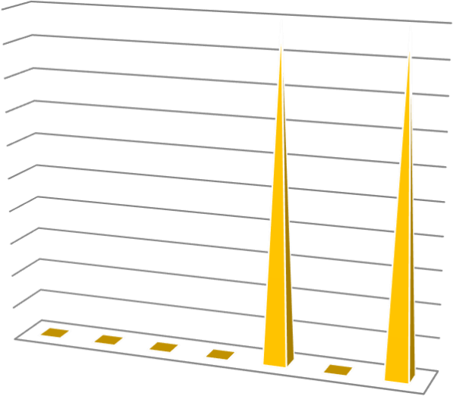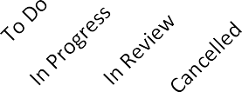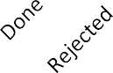

# Priority Breakdown:

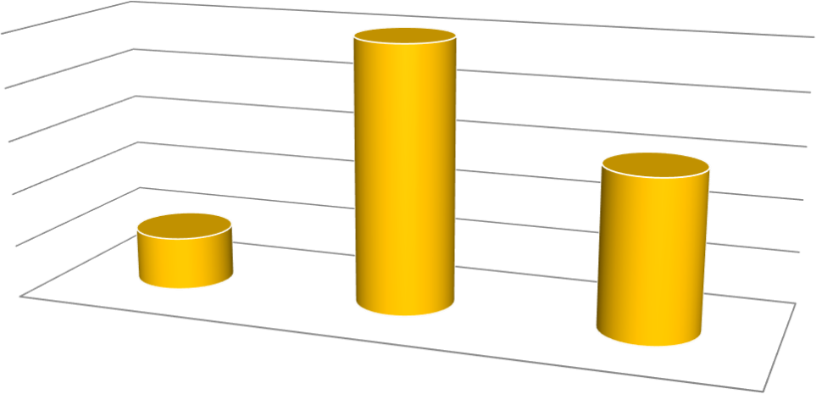

Low

Medium

High